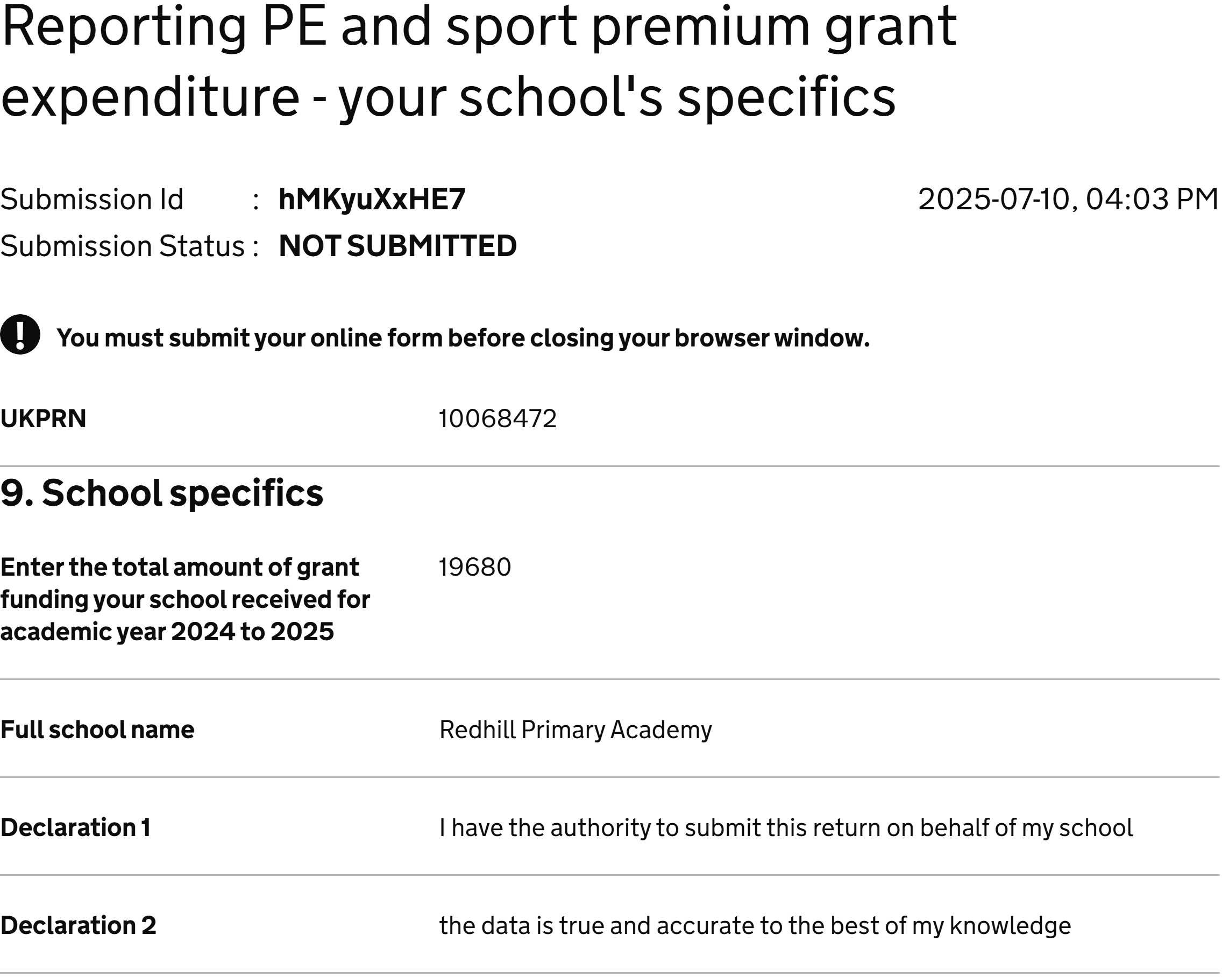

Reporting PE and sport premium… hMKyuXxHE7 Page 1 of 1